APQB 6.6 Real Interest Rates and International Capital Flows

- An increase in a government’s deficit spending will most likely affect a nation in an open economy in which of the following ways?
- The economy will experience financial capital outflows, and its currency will appreciate.
- The economy will experience financial capital outflows, and its currency will depreciate.
- The economy will experience financial capital inflows, and its currency will appreciate.
- The economy will experience financial capital inflows, and its currency will depreciate.
- The economy will experience no change in financial capital flows, and the value of its currency will not change.
- The real interest rate in Country X is 3 percent and is 7 percent in Country Y. Which of the following correctly predicts the effect of the differences in interest rates between the two countries?
- Country X will experience financial capital outflows, and Country X's currency will appreciate.
- Country X will experience financial capital inflows, and Country X's currency will depreciate.
- Country Y will experience financial capital outflows, and Country Y's currency will appreciate.
- Country Y will experience financial capital inflows, and Country Y's currency will appreciate.
- Country Y will experience financial capital inflows, and Country Y's currency will depreciate.
- A contractionary monetary policy by the Canadian central bank will likely affect international financial capital flows and the Canadian dollar in which of the following ways in the short run?
- Financial capital flows from Canada will increase, and the Canadian dollar will appreciate.
- Financial capital flows from Canada will increase, and the Canadian dollar will depreciate.
- Financial capital flows from Canada will increase, and the value of the Canadian dollar will not change.
- Financial capital flows to Canada will increase, and the Canadian dollar will depreciate.
- Financial capital flows to Canada will increase, and the Canadian dollar will appreciate.
- If real interest rates in the United States fall relative to real interest rates in Great Britain, which of the following will occur?
- British investors will buy more United States securities.
- British exports to the United States will increase.
- The supply of dollars will decrease.
- United States investors’ demand for British pounds will decrease.
- The British pound will appreciate relative to the dollar.
- Country X’s government increases its spending without raising taxes. Which of the following is true about the effect on Country X’s real interest rates and its subsequent effect on Country X’s net exports?
- Real interest rates increase and net exports increase.
- Real interest rates increase and net exports decrease.
- Real interest rates increase with no change in net exports.
- Real interest rates decrease and net exports increase.
- Real interest rates decrease and net exports decrease.
- If the central bank of Country Z wishes to increase the value of its currency on foreign exchange markets, it can do which of the following?
- Buy the currencies of other countries
- Increase the domestic money supply in Country Z
- Increase the income tax in Country Z
- Raise interest rates in Country Z
- Increase tariffs in Country Z
- Following a decrease in the real interest rate, there is an increase in financial capital outflows from Country A. The increase in capital outflows will most likely have which of the following effects on Country A’s net exports and aggregate demand?
 | Net Exports | Aggregate Demand
A | Decrease | Decrease
B | Decrease | No Change
C | Increase | Increase
D | Increase | Decrease
E | Increase | No Change
- Assume that the supply of loanable funds increases in Country X. The international value of Country X’s currency and Country X’s exports will most likely change in which of the following ways?
 | International Value of Country X’s Currency | Country X’s Exports
A | Decrease | Decrease
B | Decrease | Increase
C | Increase | Decrease
D | Increase | Increase
E | Not change | Not change

- Under a flexible exchange-rate system, the Indian rupee will appreciate against the Japanese yen when
- India’s inflation rate exceeds Japan’s
- India has a trade deficit with Japan
- Japan’s economy enters a recession, but India’s does not
- Japan’s money supply decreases while India’s money supply increases
- real interest rates in India increase relative to those in Japan
- Which of the following is likely to result in an inflow of financial capital to Country Z?
- A decrease in Country Z’s government budget deficit
- An increase in personal income tax rates in Country Z
- Increased sales of government bonds by the central bank of Country Z
- An increase in country Z’s trade surplus
- Increased political instability in Country Z
- Assume that the real interest rate in the United States increases relative to the real interest rate in Mexico. Which of the following will happen to the supply of United States dollars and the dollar exchange rate relative to the Mexican peso in foreign exchange markets?
- The supply of dollars will increase, and the dollar will appreciate.
- The supply of dollars will increase, and the dollar will depreciate.
- The supply of dollars will decrease, and the dollar will appreciate.
- The supply of dollars will decrease, and the dollar will depreciate.
- The supply of dollars will decrease and the effect on the value of the dollar is indeterminate.
- With an increase in investment demand in the United States, the real interest rate rises. In this situation, the most likely change in the capital stock in the United States and in the international value of the dollar would be which of the following?
 | Capital Stock in the United States | International Value of the Dollar
A | Increase | Decrease
B | Increase | No Change
C | Increase | Increase
D | Decrease | Increase
E | No Change | Decrease

Free Response
- Include correctly labeled diagrams, if useful or required, in explaining your answers. A correctly labeled diagram must have all axes and curves clearly labeled and must show directional changes. If the question prompts you to "Calculate," you must show how you arrived at your final answer.
Suppose that the United States government implements a fiscal policy that increases the budget surplus.
(a) Draw a correctly labeled graph of the loanable funds market and show the effect of the increase in the budget surplus on the equilibrium real interest rate.
(b) The European Union is a major trading partner of the United States. Given your answer in part (a) about the real interest rate, will the United States dollar appreciate or depreciate against the euro? Explain.
(c) Suppose that the Federal Reserve, the central bank of the United States, decides to offset the change in the value of the dollar identified in part (b).
(i) Would the Federal Reserve buy or sell the euro?
(ii) Would the Federal Reserve buy or sell the dollar?
(d) Suppose that the Federal Reserve wants to counteract the real interest rate change identified in part (a). What open-market operation would the Federal Reserve use?
- In answering the question, you should emphasize the line of reasoning that generated your results; it is not enough to list the results of your analysis. Include correctly labeled diagrams, if useful or required, in explaining your answer. A correctly labeled diagram must have all axes and curves clearly labeled and must show directional changes.
Japan, the European Union, Canada, and Mexico have flexible exchange rates.
- Suppose Japan attracts an increased amount of investment from the European Union.
- Using a correctly labeled graph of the loanable funds market in Japan, show the effect of the increase in foreign investment on the real interest rate in Japan.
- How will the real interest rate change in Japan that you identified in part (a)(i) affect the employment level in Japan in the short run? Explain.
- Suppose in a different part of the world, the real interest rate in Canada increases relative to that in Mexico.
- Using a correctly labeled graph of the foreign exchange market for the Canadian dollar, show the effect of the change in real interest rate in Canada on the international value of the Canadian dollar (expressed as Mexican pesos per Canadian dollar).
- How will the change in the international value of the Canadian dollar that you identified in part (b)(i) affect Canadian exports to Mexico? Explain.

Answer

1C 2D 3E 4E 5B 6D 7C 8B 9E 10C 11C 12C
Free Response
1
a
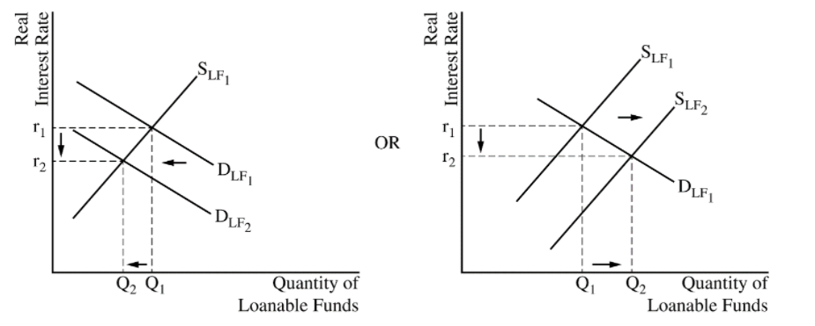
B The response states that the dollar will depreciate against the euro and explains that the demand for United States financial assets decreases which decreases the demand for the dollar or increases the supply of the dollar. (It is also acceptable to explain that as investors seek higher returns in foreign financial assets, there will be financial capital outflows, which decreases the demand for the dollar or increases the supply of the dollar.)
C The response states that the Federal Reserve should sell the euro and buy the dollar.
D The response states that the Federal Reserve should sell bonds.

2
A
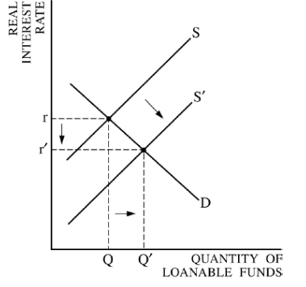One point is earned for stating that the decrease in the real interest rate caused interest-sensitive spending to increase.
One point is earned for stating that the increase in aggregate demand increases output, which causes an increase in employment.
B
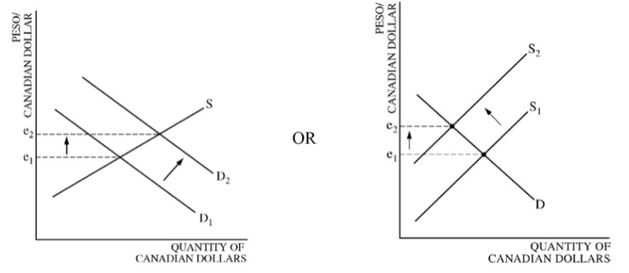One point is earned for stating that Canadian exports to Mexico will decrease because the appreciation of the Canadian dollar makes Canadian products more expensive for Mexican consumers.

Suppose that the United States government implements a fiscal policy that increases the budget surplus.
(a) Draw a correctly labeled graph of the loanable funds market and show the effect of the increase in the budget surplus on the equilibrium real interest rate.
(b) The European Union is a major trading partner of the United States. Given your answer in part (a) about the real interest rate, will the United States dollar appreciate or depreciate against the euro? Explain.
(c) Suppose that the Federal Reserve, the central bank of the United States, decides to offset the change in the value of the dollar identified in part (b).
(i) Would the Federal Reserve buy or sell the euro?
(ii) Would the Federal Reserve buy or sell the dollar?
(d) Suppose that the Federal Reserve wants to counteract the real interest rate change identified in part (a). What open-market operation would the Federal Reserve use?

Japan, the European Union, Canada, and Mexico have flexible exchange rates.
- Suppose Japan attracts an increased amount of investment from the European Union.
- Using a correctly labeled graph of the loanable funds market in Japan, show the effect of the increase in foreign investment on the real interest rate in Japan.
- How will the real interest rate change in Japan that you identified in part (a)(i) affect the employment level in Japan in the short run? Explain.
- Suppose in a different part of the world, the real interest rate in Canada increases relative to that in Mexico.
- Using a correctly labeled graph of the foreign exchange market for the Canadian dollar, show the effect of the change in real interest rate in Canada on the international value of the Canadian dollar (expressed as Mexican pesos per Canadian dollar).
- How will the change in the international value of the Canadian dollar that you identified in part (b)(i) affect Canadian exports to Mexico? Explain.

